<http://ffh.films.com/id/3900/Derek_Walcott_Pantomime.htm>

**DEREK WALCOTT (1930 - )** 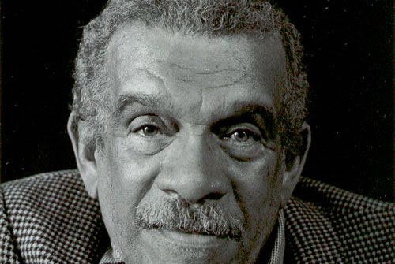

World renowned poet, playwright, and essayist, Derek Walcott won the Nobel Prize in Literature in 1992. He grew up in his birthplace, Castries, St. Lucia, immersed in the landscape, history, and creolized cultures of the Caribbean. In his writing, Walcott articulates both anguish at the wounds inflicted by the past and joy at the beauty of the West Indies. For Walcott, art is the revolutionary medium through which to seek transcendence of racial and regional divisions; he achieves universality in his art through love of what is particular to the Caribbean.

Drawing on canonical modernist influences such as Eliot, Joyce, and Yeats, and the classics of western literature that also inspired them, Walcott’s writing emerged during the West Indian cultural nationalism of the 1950s-70s and alongside the Latin American ‘boom’, developing into a postcolonial modernism. His work is especially attentive to the natural environment of the West Indies and proposes an ‘Adamic’ imagination that sees and names the ‘New World’ afresh. Much of his writing re-envisions sea-voyaging literary figures such as Robinson Crusoe and, especially, Odysseus, while also exploring the journeys taken and obstacles faced by the contemporary poet.

*

St. Lucia has been crucial to Walcott’s poetic imagination. Colonized by both the French and English, the island changed hands thirteen times until the British took over in 1814 and governed

the island until its independence in 1979. Colonial conquest and the violent importation of slaves from West Africa brought many cultures – Amerindian, African, European – into contact with one another, creating a creolized language and culture divided along colonial, racial, linguistic, and class lines. The past of slavery, the interplay of different languages and cultures, and the centuries of colonial rule that St. Lucia shared with other Caribbean islands led some writers to view the region as devoid of any true history, culture, or identity. As V. S. Naipaul famously wrote, ‘History is built around achievement and creation; and nothing was created in the West Indies.’[1] Walcott, however, along with a number of his contemporaries from the Caribbean, has sought to transform that view. In a speech published in 1974, Walcott countered Naipaul: ‘Nothing will always be created in the West Indies, for quite a long time, because what will come out of there is like nothing one has ever seen before’ (Hamner, ed., *Critical*, 54).

<http://www.saint-lucia.com/caribbean-st-lucia-map.html> <http://www.uvm.edu/cdae/?Page=stlucia.php&SM=submenus/opportunitiessubmenu.html>

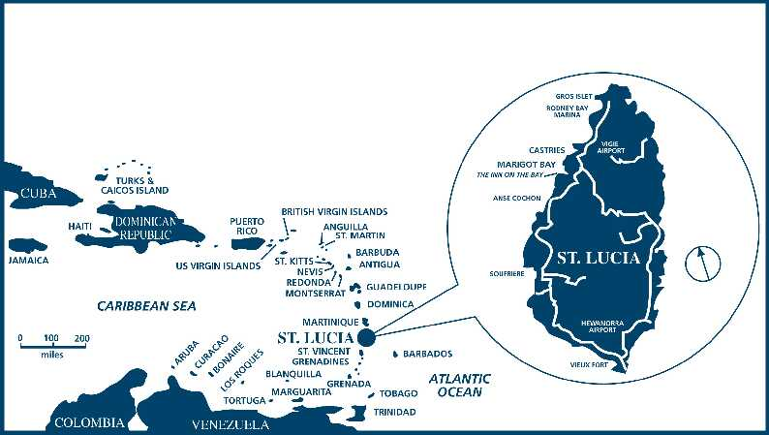 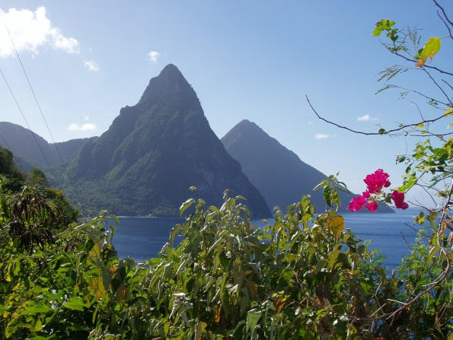

*

Walcott’s father, a civil servant and amateur painter, died when he was only a year old, but Walcott received encouragement from his mother, a school teacher, and from his father’s close friend Harold Simmons, a folklorist and professional painter. Simmons fostered his appreciation for the local landscape and culture and taught him to paint. However, he also helped Walcott to recognize that his greatest talent lay in poetry. By age nineteen, Walcott had already published two books of poetry, *25 Poems* (1948) and *Epitaph for the Young* (1949). From 1950-53 he attended the newly opened University of the West Indies at Mona, Jamaica where he became active in literary and dramatic societies and edited the student newspaper. Following graduation, he taught in secondary schools and later became a feature writer for *Public Opinion* in Jamaica where he published articles on the arts.

In 1958, Walcott’s career took a crucial turn with his move to Trinidad where he founded the Trinidad Theatre Workshop. He had written plays from the time he was a teenager, and several had been performed throughout the Caribbean including *The Sea at Dauphin*, *The Wine of the Country*, *Ti-Jean and His Brothers*, and *Drums* *and Colors*. While directing the Workshop from 1959-76, he completed the play many consider his best, *Dream on Monkey Mountain* (1970) and wrote essays expressing his artistic vision, including ‘What the Twilight Says’ (1970), ‘The Muse of History’ (1974), and ‘The Caribbean: Culture or Mimicry?’ (1974). During these years he also published five books of poems - *In a Green Night: Poems 1948-1960* (1962), *Selected Poems* (1964), *The Castaway and Other Poems* (1965), *The Gulf and Other Poems* (1970, and *Sea Grapes* (1976) – and the long autobiographical poem *Another Life* (1973).

The 1960s and ‘70s were fraught with political tensions that shaped Walcott’s writing and career. The West Indian Federation, which some critics see as a key influence on his ideals of unity across racial and regional divides, failed in the 1960s, and the Black Power movement arose in the 1970s, promoting an Afrocentric ideology with which he disagreed. In this conflicted period, he further developed his own controversial theories of art and identity.

Questions of cultural, national, and racial identity had already formed Walcott’s poetry, beginning with early poems such as the often quoted ‘A Far Cry from Africa’ (1962) in which the speaker asks, ‘Where shall I turn, divided to the vein?. . .how choose/ Between this Africa and the English tongue I love?’ (*Collected*, 18). This sense of a deeply divided identity stemmed partly from Walcott’s mixed ancestry. His grandfathers were white and wealthy, one English from Barbados and the other Dutch from St. Maarten, while his grandmothers were of mostly African descent and poor. Additionally, his middle class education and love of English literature could seem to conflict with his love of St. Lucia and its predominantly poor and illiterate Afro-Caribbean populace. In later works, such as *The Schooner Flight* (1979) and *Omeros* (1990), mixed ancestry and the creolization of cultures and languages in the Caribbean became an acknowledged, even celebrated, source of creativity.

But in the early 1970s, critics cast his work as Eurocentric, especially in contrast to the work of Barbadian poet Kamau Brathwaite. Walcott responded to the simplistic opposition of African and European orientations by cautioning against ‘African tourism’ and a notion of power ‘based on genetics’ (*Twilight*, 57). At the same time, he also rejected the view of Caribbean art and artists as necessarily derivative of European models. Addressing the charge of imitation in Caribbean art, he has not argued against it by asserting Caribbean originality, but by claiming imitation as an authentic artistic practice that leads beyond mimicry to invention. For Walcott, no culture is wholly original, and the Caribbean artist brings together fragments of many and shapes them into something new. In his Nobel Prize lecture ‘The Antilles: Fragments of Epic Memory’ (1992), he makes clear the multiplicity of these cultures, referring not only to African and European but to South Asian, Chinese, Lebanese, Islamic, and Sephardic Jewish presences in the Caribbean. Of the poet’s craft, he states, ‘Break a vase, and the love that reassembles the fragments is stronger than that love which took its symmetry for granted when it was whole’ (*Twilight*, 69).

Repudiating the notion of European originality, Walcott has also rejected Western imperial history as a narrative of truth concerning the past. He is not interested in history for either colonialist or anti-colonialist purposes, but rather in a mythopoetics that begins with the vision of a new Adam, the poet who can see and name the Americas with fresh eyes. For him, Walt Whitman, Pablo Neruda, St. John Perse, Aimé Césaire, Denis Williams, and Wilson Harris all convey an ‘elation which sees everything renewed’ (*Twilight*, 38). This does not mean he rejects knowledge of history; rather that he locates the truth of the past elsewhere. In ‘The Schooner *Flight*’, for example, the speaker and poet Shabine ships out as a seaman in the Caribbean where he imaginatively encounters the past of the Middle Passage and of the murderous attacks on Caribs in Dominica. These collective traumatic experiences lead him to reject ‘Progress’ as ‘history’s dirty joke’ (*Collected*, 356). ‘The Sea Is History’, published the same year, begins with a schoolboy’s answer to the question, ‘Where are your monuments, battles, martyrs?’ The boy replies, ‘Sirs, / in that gray vault. The sea. The sea/ has locked them up. The sea is History’ (*Collected*, 364).

*

In Walcott’s poetry, formal poetic devices become a language through which such questions of history, identity, and art itself are posed. In *Another Life* (1973) and other long poems, including *Omeros* (1990) and *Tiepolo’s Hound* (2000), Walcott explores the relationship between artist and artwork through *ekphrasis*, or the verbal description of visual art. In these meditations on English landscapes, vases from ancient Greece, or 18th-century Venetian paintings, he reflects also on the conflicts and complexities of identity within the context of empire. These ekphrastic passages reveal connections between, for example, his own position as poet/painter and that of a young black man, ‘the Moor’, portrayed in a painting by Tiepolo and described in *Tiepolo’s Hound*, a long poem illustrated with Walcott’s own watercolors. Similarly, in Walcott’s use of traditional poetic forms, such as the Dantesque *terza rima* in *Omeros* or the couplet in *Tiepolo’s Hound*, he does more than simply follow European poetic conventions. Rather he alters them to convey the unique cultural crossings of the Caribbean. Walcott’s rhymes can lend force to connections made between cultures and to paradoxes central to the Caribbean past. Giving Caribbean history and culture new meaning through traditional forms renews both.

<http://www.amazon.com/Tiepolos-Hound-Derek-Walcott/dp/0374105871>

<http://www.amazon.com/Omeros-Derek-Walcott/dp/0374523509>

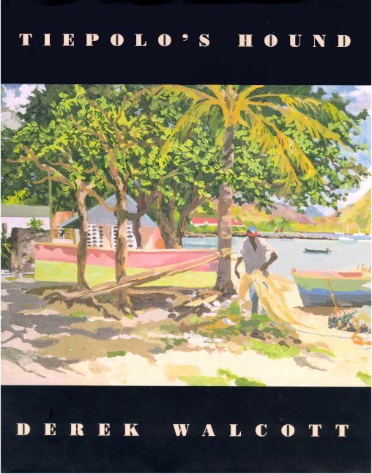 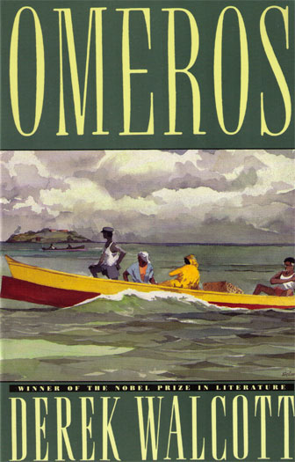

In *Omeros*, Walcott renews the epic in what he has described as ‘a combination of a Homeric line and a Dantesque design’ (Breslin, 245). He has resisted the label of ‘epic’ for this poem, however, since its characters are not heroic in the conventional sense; nevertheless, the poem contains many epic elements including invocations of the muse, sea journeys and homecomings, catalogues of battles, and names such as Achille, Hector, and Helen that allude to the classical Greek epics. In many ways, *Omeros* creates a foundational story for a people. These elements of the epic combine with the novelistic feel of its strong narrative impulse, the rich patterns of metaphor and rhyme, and its intense lyricism to create a unique interplay of genres. Through a global geographical reach and deeply layered temporality, the poem reveals its wounded, divided, and questing characters to be deeply interconnected. Simultaneously, it chronicles the quest for a poetic language worthy of Helen, both an ordinary woman and also the island, St. Lucia, known as the Helen of the West Indies. The poet discovers that, ‘Like Philoctete’s wound, this language carries its cure, / its radiant affliction;’ (323).

*

Questions of history and myth have shaped Walcott’s continuing interest in the theatre in plays such as *The Haitian Earth* (1984), *The Ghost Dance* (1989), *Walker* (2001) *The Odyssey* (1992), and *Marie Laveau* (2012). He has also continued to explore the ethics of poetic creation and to figure the natural environment as sacred space. Mourning his mother in the title poem of *The Bounty* (1997), the poet reflects anew on the relation between art and life, wondering whether his own poetic lines will ‘harden me // into sorrow as measured as this’ (5). The title poem of *White Egrets* (2010) remembers a friend, now dead, through the ‘seraphic souls’ of the egrets, whose flight astonishes and whose beaks become metaphors for the poet’s pen. Acknowledging the alternate sounding of ‘with regrets’ in the title, the poems in *White Egrets* reflect on the losses of aging and imagine ‘that peace / beyond desires and regrets’ (6).

Walcott has travelled extensively since the late 1970s, spending time in the United States where he has taught at Columbia, NYU, Harvard, and Boston University. He has also journeyed through Europe and Latin America, casting himself as an Odyssean figure, especially in the long poem *The Prodigal* (2004). Even with the profound homecoming portrayed at the conclusion to this poem, however, his poetic persona remains multiple, reflected in the images of others and in varying pronouns – ‘he’, ‘we’, ‘I’, and ‘you’ – as he continues to seek and question.

Selected references and further reading:

Baugh, E. (2006) *Derek Walcott*, Cambridge: Cambridge University Press.

Breslin, P. (2001) *Nobody’s Nation: Reading Derek Walcott*, Chicago: University of Chicago Press.

Burnett, P. (2000) *Derek Walcott: Politics and Poetics*, Gainesville, FL: University Press of Florida.

Hamner, R., ed. (1993) *Critical Perspectives on Derek Walcott*, Washington D. C.: Three

Continents Press (includes several essays by Walcott).

Hamner, R. (1997) *Epic of the Dispossessed: Derek Walcott’s* Omeros, Columbia, MO: U of

Missouri Press.

King, B. (2000) *Derek Walcott: A Caribbean Life*, Oxford: Oxford University Press.

Thieme, J. (1999) *Derek Walcott*, Manchester and NY: Manchester University Press.

Tynan, M. (2011) *Postcolonial Odysseys: Derek Walcott’s Voyages of Homecoming*, Newcastle

upon Tyne: Cambridge Scholars Publishing.

List of Works:

Poetry

*Derek Walcott: Collected Poems, 1948-84* (1986)

*In a Green Night, Poems 1948-60* (1962)

*The Castaway and Other Poems* (1965)

*The Gulf and Other Poems* (1969)

*Another Life* (1973)

*Sea Grapes* (1976)

*The Star-Apple Kingdom* (1979)

*Selected Poetry*, ed. Wayne Brown (1981)

*The Fortunate Traveler* (1981)

*The Caribbean Poetry of Derek Walcott and the Art of Romare Beardon* (1983)

*Midsummer* (1984)

*The Arkansas Testament* ((1987)

*Omeros* (1990)

*The Bounty* (1997)

*Tiepolo’s Hound* (2000)

*The Prodigal* (2004)

*Selected Poems*, ed. Edward Baugh (2007)

*White Egrets* (2010)

Published Plays

*Harry Dernier* (1952)

*Dream on Monkey Mountain and Other Plays* (1970)

*The Joker of Seville and O Babylon!* (1978)

*Remembrance and Pantomine: Two Plays* (1982)

*Three Plays* (1986)

*The Odyssey: A Stage Version* (1993)

*The Haitian Trilogy* (2002)

*Walker and The Ghost Dance* (2002)

*Marie LaVeau and Steel: Plays* (2012)

Essays and Print Interviews

*The Antilles: Fragments of Epic Memory, the Nobel Lecture* (1993)

*Conversations with Derek Walcott*, ed. William Baer (1996)

*What the Twilight Says: Essays* (1998)

On-Line Readings and Interviews

“The Sea Is History,” November 23, 2010. Walcott reads from “The Light of the World” and speaks in an interview with Christopher Campbell at Hart House, the University of Toronto:

<http://www.youtube.com/watch?v=d_6mgbRSUzo&feature=related>

“Derek Walcott,” April 6, 2007. Walcott gives a talk and reads from *Omeros* in the Mandell Weiss Theater at Marshall College, UCSD:

<http://www.youtube.com/watch?v=-0T3KPmc6ZM&feature=related>

[http://www.nobelprize.org/nobel_prizes/literature/laureates/1992/#](http://www.nobelprize.org/nobel_prizes/literature/laureates/1992/)

Contributor: Mary Lou Emery

1. V. S. Naipaul, *The Middle Passage* (NY: Vintage, 2002, orig. pub. 1962): 25.